Chronotopia – Electronic and experimental music initiative
Online lectures, open for all
29, 30, 31 Μαρτίου

29 March 2021, 18.00 – 19.30: Andrey Smirnov
30 March 2021, 18.00 – 19.30: Eleni Ikoniadou
31 March 2021, 18.00 – 19.30: Wolfgang Ernst

Watch the trailer here.
Chronotopia is an international collaboration between Athens and Epidaurus Festival, Goethe Institut Athen and Berlin's CTM festival. Points of contact between past and current music, sound, and media practices are explored, for instance via re-articulations of pre-modern musical forms and practices, media-archeological research, or archives amongst others.
Last November and December the electronic music composition lab Αντηχήσεις / Echoes was held online under the guidance of Greek sound artist and researcher Akis Sinos and German sound artist and researcher Anke Eckardt. The lab was aimed to professional composers and sound artists, and the six participants were chosen among dozens of submissions. Following research at the archive of the Contemporary Music Research Center (CMRC) in Athens, each participant created an original work of electronic music, drawing on material from past music. The six original sound works will be presented at Peiraios 260 as part of Athens Festival 2021.
Prior to the live presentations, audiences will have the opportunity to participate in Chronotopia Echoes / Αντηχήσεις, attending a series of online lectures on 29, 30 and 31 March 2021. Guest lecturers include interdisciplinary artist, researcher, founder of Theremin Centre and lecturer at the Rodchenko Art School in Moscow, Andrey Smirnov, Senior Tutor in Visual Communication and leader of the Experimental Communication pathway at London’s Royal College of Art, Eleni Ikoniadou, and Full Professor for Media Theories at the Institute for Musicology and Media Science at Humboldt University in Berlin, Wolfgang Ernst.
Lectures can be attended free of charge, on a first-come, first-served basis. Registration is mandatory (maximum number of participants: 25 persons). Applications submitted exclusively at: workshops@ctm-festival.de
Applicants must mention the name of the lecturer or lecture they wish to attend in the subject line. Registration will remain open until midnight CET on the day before each lecture.
Lectures will be in English. No translation will be provided.

The lectures:
March 29th: Andrey Smirnov
RevArsAvr: Backwards to the Future
This lecture focuses on revolutionary composer Arseny Avraamov and his article ‘Upcoming Science of Music and the New Era in the History of Music’ (1916) as a manifesto and a major program for future creative research and developments in music and related sciences. While in Soviet times the name of Arseny Araamov as well as his theoretical works were largely forgotten, in July 1940 one of the leading Russian composers Mikhail Gnesin asserted: ‘A. Avraamov should also be recognized as a founder of Soviet musical acoustics’. In turn, most Russian inventions and developments (the Theremin, Graphical Sound, the Rhythmicon, ANS Synthesizer etc.) might be considered as direct or indirect consequences of Arseny Avraamov’s manifesto.

March 30th: Eleni Ikoniadou
Future Chorus
Imagine a chorus of voices—some human, some animal, some machine—arriving from an unknown space and time to perform a lament. Laments are extreme expressions of grief in the form of a song or poem. In ancient tragedy, a chorus typically (re)turns to the past to scan history for a precedent in search for meaning of the present. On this occasion, the chorus travels to the past not to learn from it but to rewrite it, from the perspective of those voices silenced by the archive.

March 31st: Wolfgang Ernst
Where “time” takes “place”
Media-Archaeological Thoughts on the (Musical) Topologization of Chrónos in the Archive, and as (Sonic) Technológos
The Chronotopical Question
In a variation of Marcel Proust's seminal novel title, A la recherche du temps perdu, and in a word play with the term chronotopia itself, this lecture will be asking: Where does “time” take place at all? This talk will first discuss how our actual videoconferencing media determine our communicative co-presence, followed by a (re-) definition of the very term “chronotope”, with a reference to Michel Foucault's seminal text Of Other Spaces. The musical “archive” will be contrasted with the sonic "recording" with a focus on symbolic music vs. actual sound in the CMRC institution and archive. The closer we focus on “time”, the more remote this parameter becomes, dissolving into a multitude of cultural techniques and technological operations. More radically “time”, as a reasonable and plausible parameter of analysis, itself gets lost in the present media condition.
More information on the content of the workshops and the bios of the three lecturers can be found at http://greekfestival.gr/open-plan-chronotopia-open-online-lectures-for-all-on-march-29th-30th-31st

A collaboration of Goethe-Institut Athen with Athens and Epidaurus Festival, Berlin’s CTM Festival and CMRC.
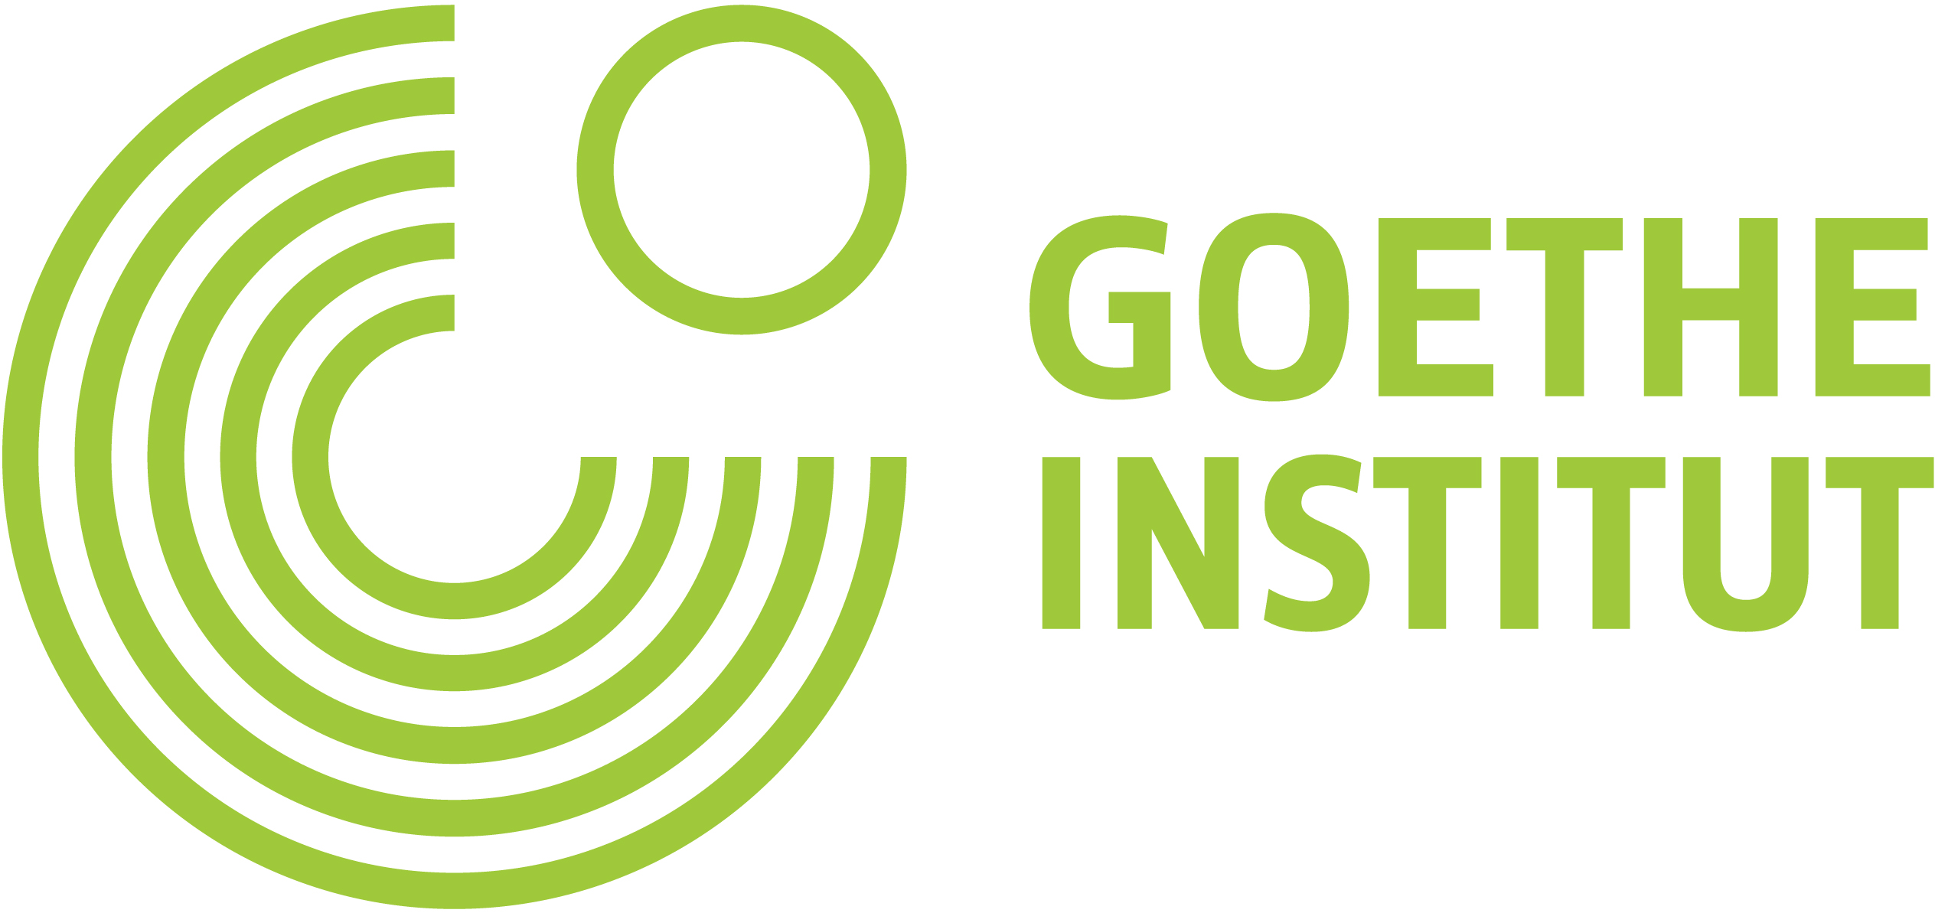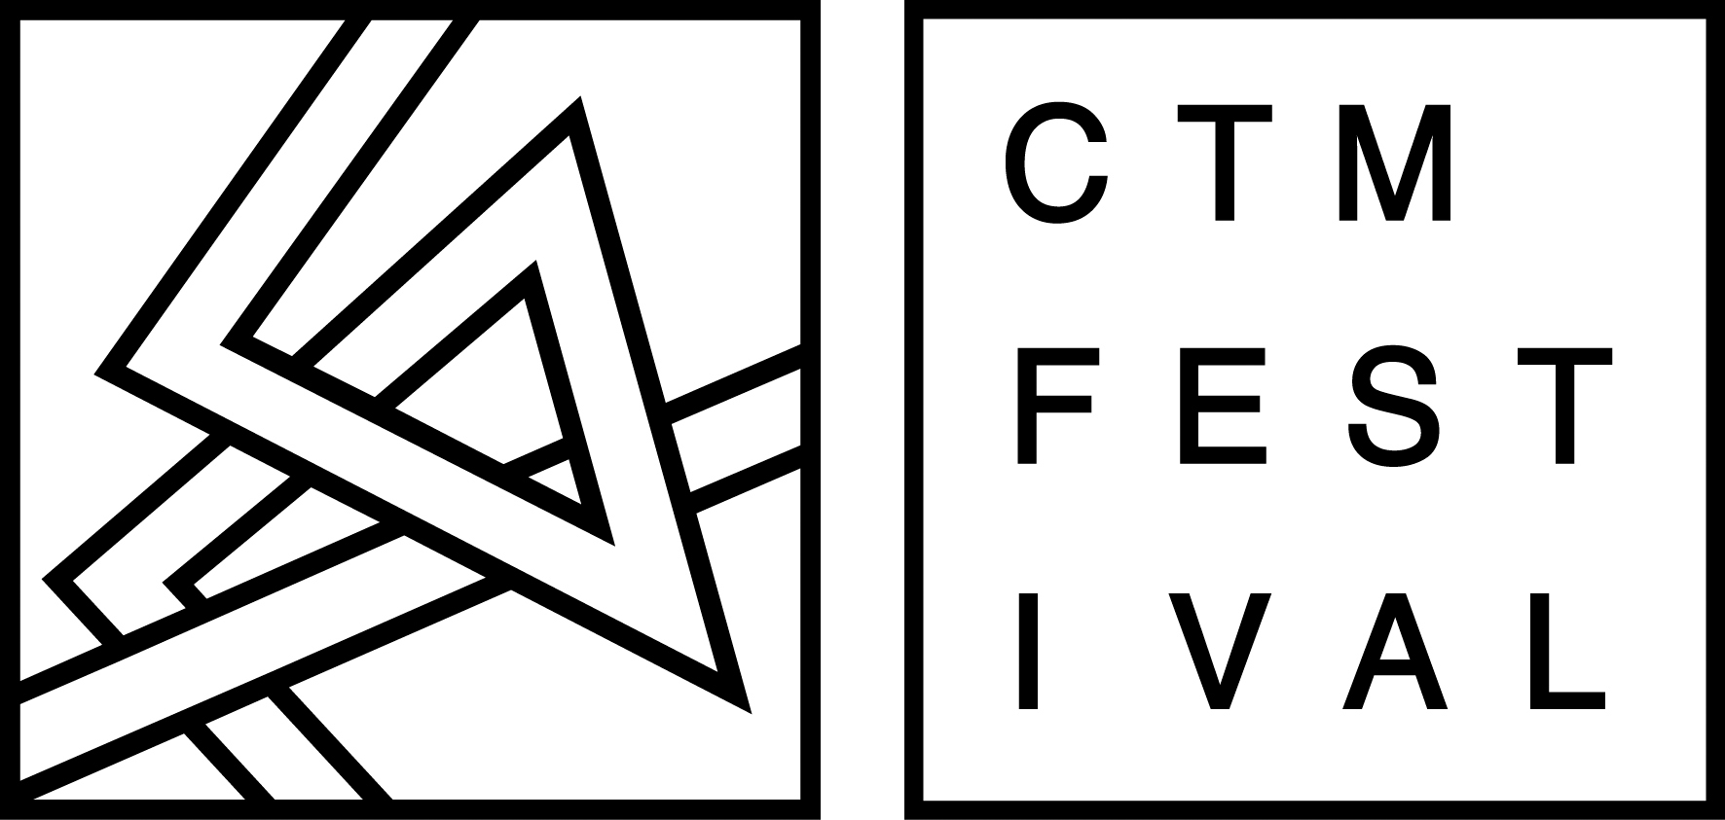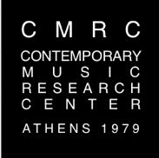

The Athens and Epidaurus Festival is funded by the Ministry of Culture and Sports.
Grand Sponsor

