RE-PRESENTATIONS
Online streaming of selected performances
by the Athens & Epidaurus Festival
As part of the initiative of the Hellenic Ministry of Culture and Sports
“We Stay at Home with Culture”

Continuously active over a period spanning 65 years, the Athens & Epidaurus Festival has made our summers richer and fuller by offering a variety of excellent performances and concerts. Many of these shows have been videotaped, thus comprising an invaluable archive. Most of these tapes, however, have not been digitised yet, meaning that this archive material is not available to audiences in its entirety.
Drawing on this rich audiovisual footage, the Festival responds to the initiative of the Hellenic Ministry of Culture and Sports “We Stay at Home with Culture” by providing free online streaming of memorable performances and concerts that have left their mark on the Athens & Epidaurus Festival in recent years, especially those videotaped in a format that allows their broadcast. While it is our belief that the streaming of videotaped performances could never substitute the live experience of a performative event, through this gesture we hope to stay in touch with our audiences by sharing unique, standout moments from the long history of the Athens & Epidaurus Festival.
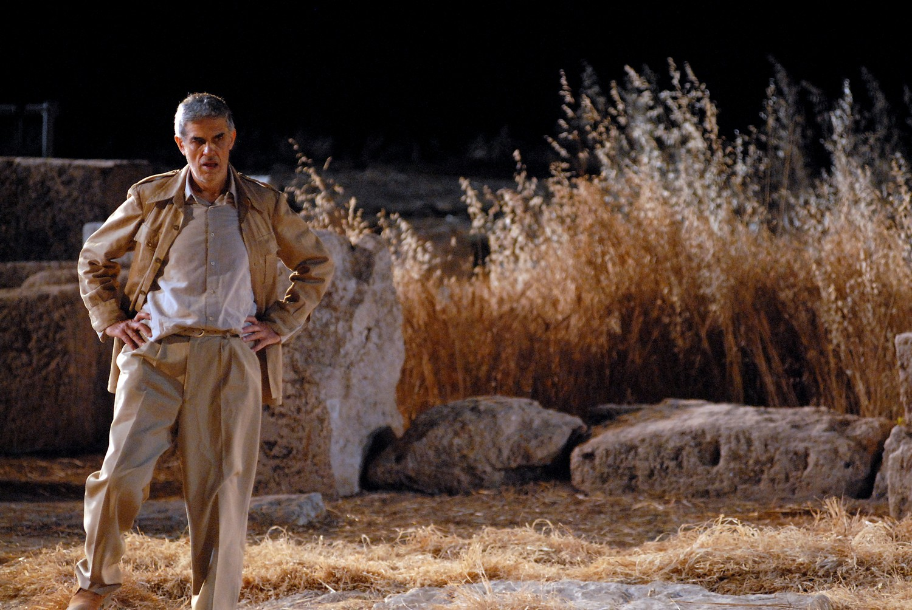
Our first selection, as part of this initiative, is a celebrated production of Sophocles’ Antigone, directed by Lefteris Voyatzis and presented at the Ancient Theatre of Epidaurus. The performance was so well-received at its premiere in 2006 that it was repeated the following year – a feat unusual by Festival standards –, opening the 2007 Epidaurus Festival. Audiences will have the opportunity to watch this second version online on our official YouTube channel, on Saturday 25th April, starting at 19:00 for a total of 24 hours.
Online streaming of more Festival performances will gradually follow. Make sure you follow us on our website and social media, where we will keep you posted on things to come.
Enjoy!
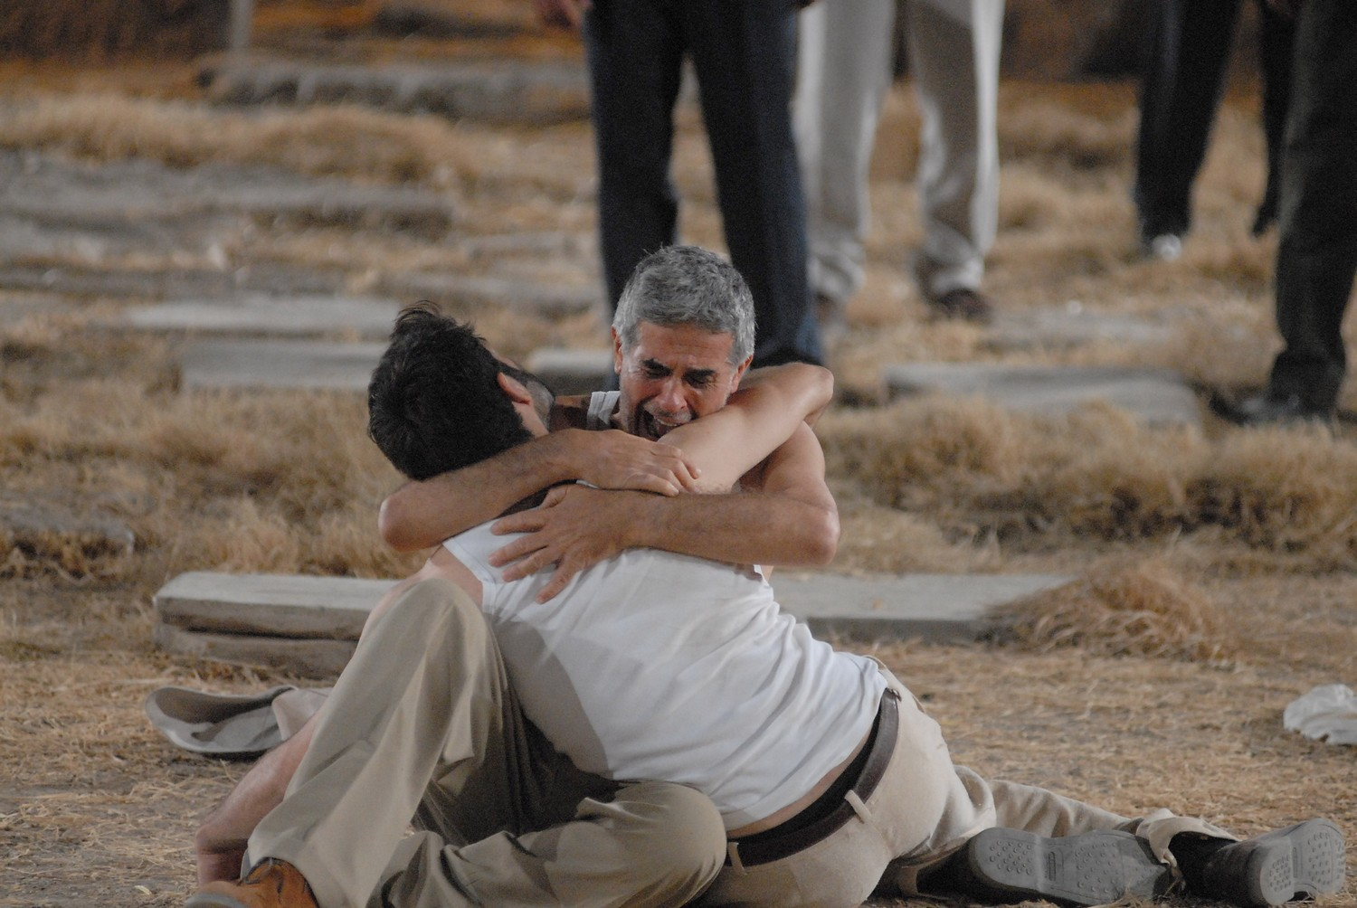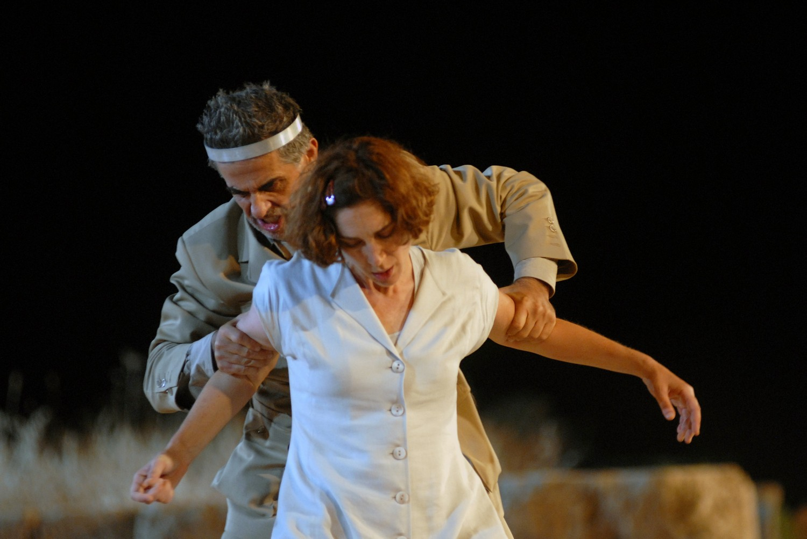

∗
Artistic Director’s Note
Live Theatre, Music, Dance are not at risk from such short-lived solutions, borne out of necessity in order to quench our thirst for art. We offer you unique moments from the Festival’s History, hoping to see you all again soon at our Venues.
We kick off this initiative with a streaming of Sophocles’ Antigone, directed by the late, great Lefteris Voyatzis – a performance with which I have a deep personal connection. Back in 2006, I worked on this production during a six-month period of preparation. As a beginner myself back then, I watched it come to life, from the very first syntactic analysis of the ancient text, a walk down memory lane as it reminded me of my high school years, to the standing ovation at the Epidaurus theatre; a once-in-a-lifetime experience that defined me; a performance etched in the memory of all those who have watched it. We hope you will enjoy its re-presentation, its passage through Time, in order to (re)taste its genuinely rare energy. A spring gift by all of us here at the Athens & Epidaurus Festival.
Behind every work there is always the sweat and toil of many individuals. Our heartfelt thanks go to all the artists who gave us permission to broadcast their work.
Katerina Evangelatos
∗
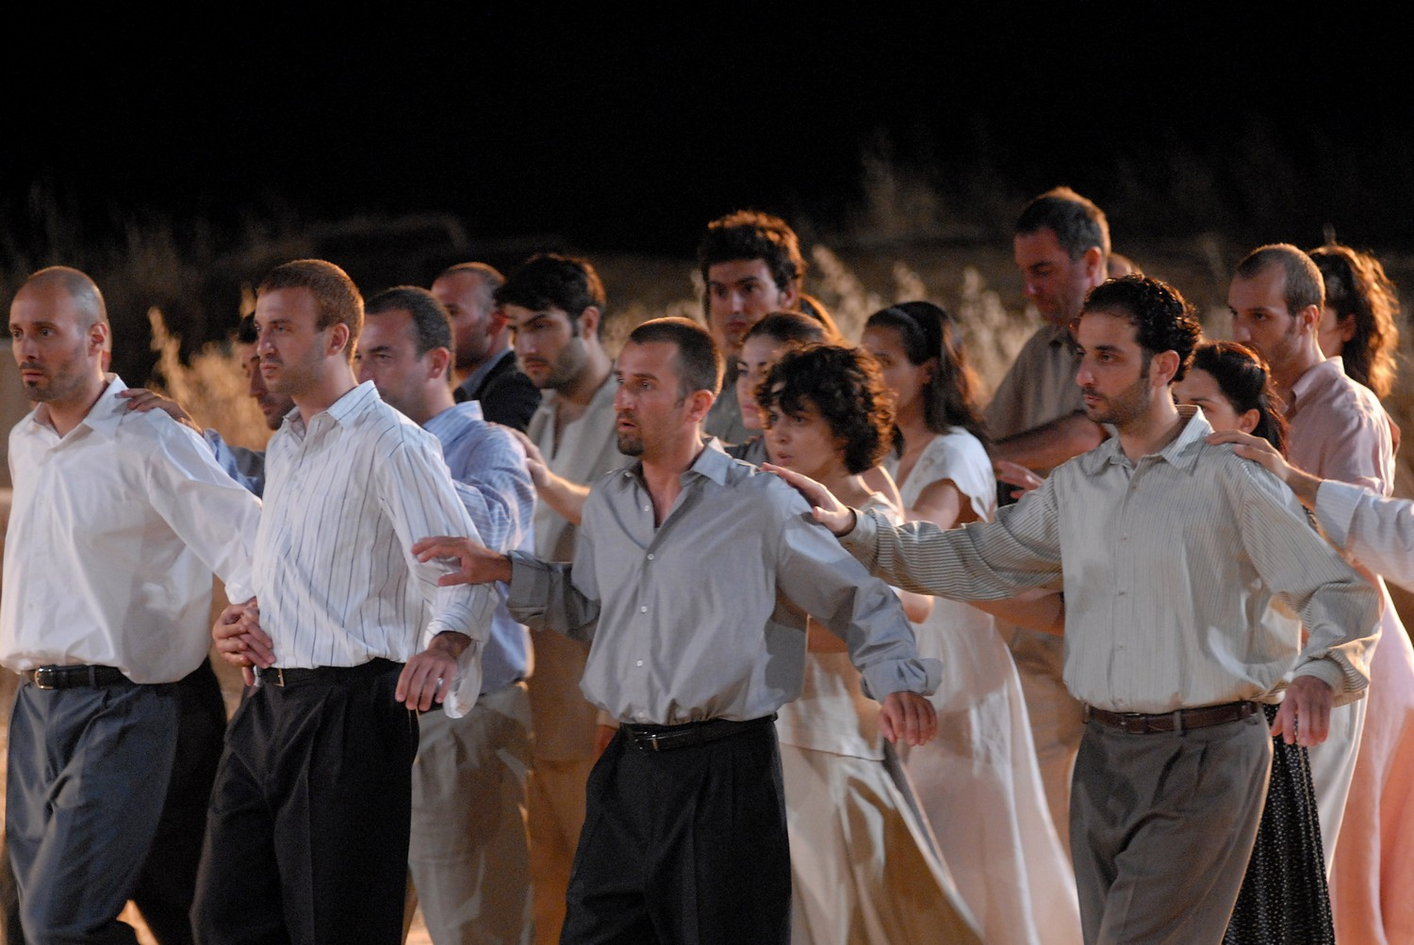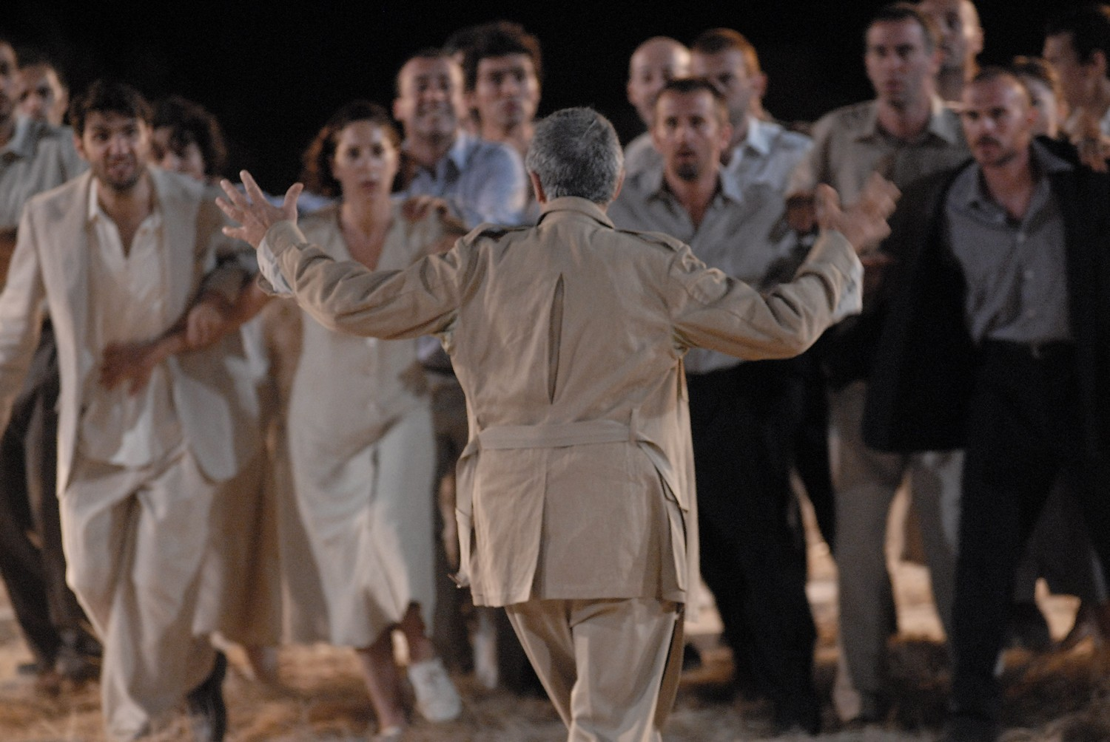

Disclaimer: Performances have been videotaped as a visual documentation of the Festival’s history and were not intended for public broadcast. We therefore ask for the audience’s understanding for any technical issues.

Performance in Greek only

Streaming starts on 25/4/2020 > 19:00, Runtime 24 hours
YouTube: Greek Festival
Athens & Epidaurus Festival 2007
Antigone by Sophocles

Translated by Nikos Panagiotopoulos • Directed by Lefteris Voyatzis • Set and costume design Chloé Obolensky • Vocal coaching - Composition and arrangement of musical themes Spyros Sakkas • Movement Hermis Malkotsis • Lighting design Lefteris Pavlopoulos • Assistant directors Katerina Evangelatos, Vangelis Zlatintsis • Assistants to the set designer Malika Chaveau, Sofia Katsilieri • Set construction Vassilis Sakkis • Costume manufacturer Panagiota Tsopanaki • Lighting operator Panagiotis Psychas • Assistant lighting designer Nikos Vlasopoulos • Set dresser Christos Mavros • Production manager Varvara Lazaridou

Cast Amalia Moutousi (Antigone), Evi Saoulidou (Ismene), Lefteris Voyatzis (Creon), Dimitris Imellos (Watchman), Nikos Kouris (Aemon), Aglaia Pappa (Tiresias), Alexia Kaltsiki (First Messenger), Nikolas Papagiannis (Eurydice), Rinio Kyriazi (Second Messenger) • Chorus Dimitris Agartzidis, Thanassis Chalkias, Harris Charalambous, Menelaos Chazarakis, Thanasis Dovris, Konstantinos Giannakopoulos, Dimitris Imellos, Alexia Kaltsiki, Giannis Klinis, Panagiotis Klinis, Kostis Koroneos, Nikos Kouris, Rinio Kyriazi, Vera Lardi, Stratos Menoutis, Amalia Moutousi, Nikolas Papagiannis, Aglaia Pappa, Apostolos Pelekanos, Spyros Perdiou, Evi Saoulidou, Dimitris Sdrolias, Amalia Tsekoura, Thanasis Vlavianos, Lefteris Voyatzis

Photo credit: Evi Fylachtou
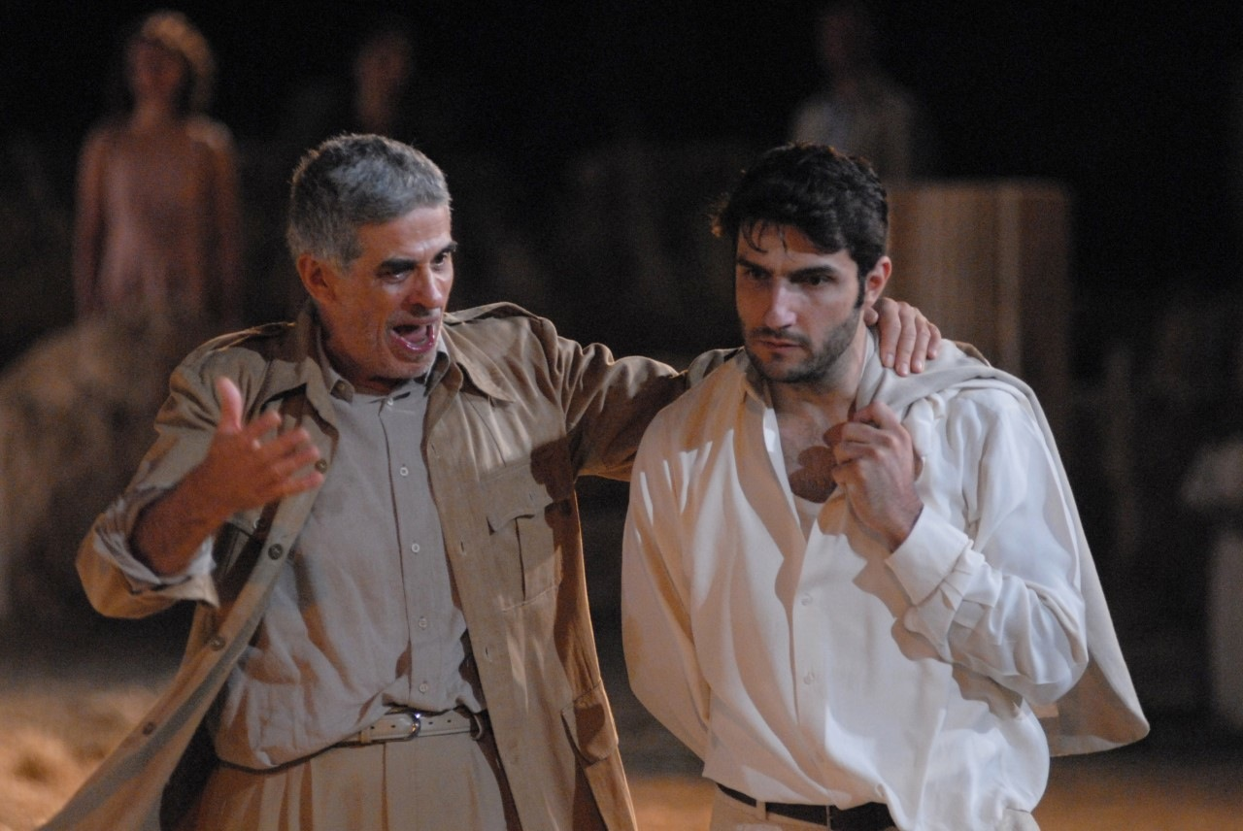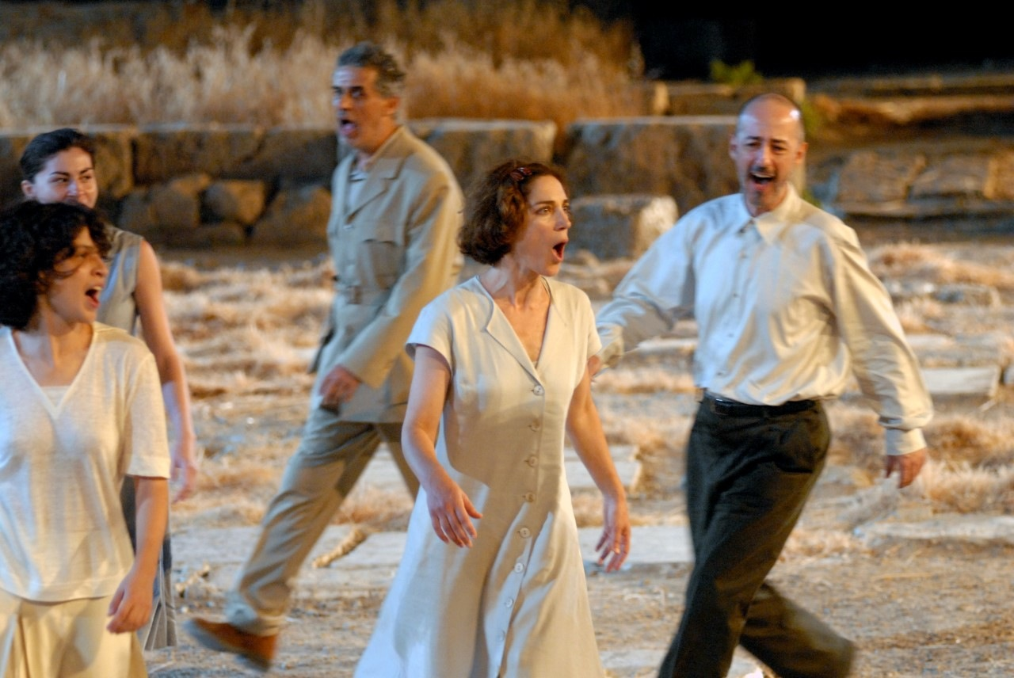

Watch the Athens & Epidaurus events:
Website www.greekfestival.gr
YouTube Greek Festival
Facebook AthensAndEpidaurusFestivalGr
Instagram athensandepidaurusfestival

