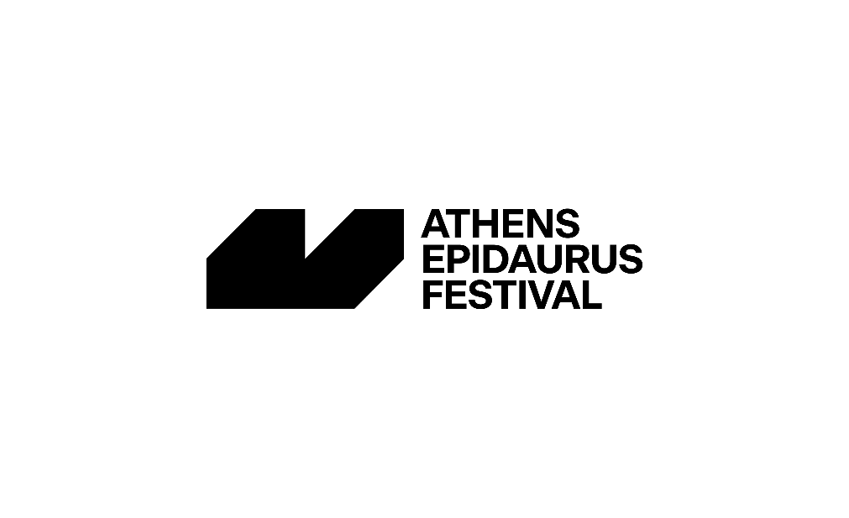
NOTE BY THE ARTISTIC DIRECTOR
This summer, the Athens Epidaurus Festival will reach its seventieth year of operation. Seventy years of unwavering artistic activity and fruitful dialogue with both the local and international scene. To honour this milestone, we have compiled a series of special and large-scale works, which we are proud to include in our programme.
Today, we are delighted to unveil the programme of Epidaurus, featuring a total of eight events. In detail, we will have the chance to enjoy four Festival productions and co-productions, performances with the signature of our two national theatres, and two independent productions. Please note that seven out of these eight works will have their world premiere at the Ancient Theatre of Epidaurus.
Audiences will have the opportunity to experience leading directors in worldwide premieres of monumental works from the canon of Ancient Drama; international co-productions and new works inspired by Ancient Drama, written by distinguished contemporary playwrights within the framework of the Contemporary Ancients Cycle; and finally, a special evening of classical music, presented as an exception at Epidaurus.
At this point, I wish to emphasise once again how vital it is to present works at the Ancient Theatre of Epidaurus that were specifically conceived and produced for its unique space. This year, urged by our anniversary celebration, we complement our programming with four special productions—three theatrical performances and a concert—which will premiere at Epidaurus. Please let me again note that three of these performances will conclude their journey here, as they will not proceed to the touring phase.
Such singular works are indeed particularly complex in nature, both in terms of their demanding artistic conception and the logistical challenges they entail. On our part, we can confidently say that we would not be in the position to present them to you today without the support of our steadfast companion in our artistic quest, the Greek Ministry of Culture, as well as the extremely generous contribution of a grand donor.
It is therefore our pleasure to announce our collaboration with the Stavros Niarchos Foundation, the Grand Donor of the Epidaurus Anniversary Programme. Thanks to its invaluable and courteous contribution, we are able to realise remarkable productions and co-productions this year, showcasing at Epidaurus prominent Greek and international artists from the fields of theatre and classical music—two art forms that the Festival has ardently maintained at the forefront of our country’s cultural landscape during its seventy years of operation.
We would like to extend our warmest gratitude for this grand donation, which marks and inaugurates a new collaboration between the Festival and the Stavros Niarchos Foundation on the occasion of the grand celebration of Culture we have envisioned for the summer of our Anniversary Year, 2025.
Seventy years of the Athens Epidaurus Festival. Seventy years of Culture, with humanity at the core of our mission—nurturing a dialogue between Art and Society, approaching cultural production as a locus of encounter, a bridge that connects people and communities. The Festival remains attuned to the pressing issues of our times, reaching the audience not only through the contemporary themes and sensibility of its performances but also through notable initiatives that we are pleased to highlight on the occasion of this anniversary.
Today, as we present the programme for the Ancient Theatre of Epidaurus for summer 2025, along with the Little Theatre of Epidaurus for July—the August programme, entirely dedicated to music, will be announced soon, along with the Festival’s programme in Athens—I would like to outline the key pillars that define the Epidaurus Festival, which also crystallise our objectives in recent years.
Epidaurus means Festival. And Epidaurus means Ancient Drama. A cornerstone of our programming and a constant protagonist remains Ancient Drama and its evolution through the years.
The Festival has established initiatives to foster research into Ancient Drama and the evolution of its tradition. A Festival with seventy years of history must always have its gaze turned to the future, even if this means that sometimes it has to take risks by diving into the unknown—yet with its compass firmly fixed to present-day human needs.
Our enduring mission then is to create a bridge that connects the legacy of Ancient Drama with today’s performing arts and dramaturgical quests, rather than investing our efforts to reconstruct or portray—almost in a museological manner—how these works/performances were allegedly performed in the past. As a result of this, it is our firm aspiration to give birth to works and performances that are relevant to contemporary audiences while at the same time deepening the viewers’ perspective on art and the world at large.
To this end, we have undertaken focused efforts and implemented strategic actions to strengthen contemporary dramaturgy, always in dialogue with the ancient texts—texts that still resonate today and challenge us to reflect on them boldly and with fresh insight.
One of the signature initiatives in this direction is the Contemporary Ancients Cycle, which commissions new theatrical works that refer to the timeless source of Ancient Drama, from their initial creation to their staging and publication. Currently in its fifth year, this Cycle was specifically conceived for Epidaurus—both for the Ancient Theatre of Epidaurus and the Little Theatre of Epidaurus—where it has framed the presentation of thirteen new works from 2021 to 2024—works that not only have been published but have also forged a new theatrical lineage for the Festival. Among the distinguished playwrights and creators who have responded to our call in recent years and graced the Cycle with new works are Maja Zace and Tiago Rodrigues (at the Ancient Theatre of Epidaurus), Christos Chomenidis, Vangelis Hatziyannidis, Amanda Michalopoulou, Vivian Stergiou, and Giannis Mavritsakis, among others.
The Contemporary Ancients Cycle is significantly enriched, welcoming more works across various genres.
In addition to Wajdi Mouawad’s play at the Ancient Theatre of Epidaurus, this year’s July at the Little Theatre of Epidaurus is purely dedicated to the programme and objectives of the Cycle. Beginning with the educational programme Parodos, it culminates in five works inspired by Ancient Drama—not strictly theatrical but also music-theatre and film projects. As a shared feeling among the team, I am particularly pleased to say that this year, the cycle enters a new phase, embracing a more fluid and free artistic expression, blending genres and languages, while always remaining rooted in Ancient Drama and its contemporary legacy.
In addition to the creation of new works inspired by myth and Ancient Drama, our foremost intention remains the systematic invitation of renowned international directors—representatives of innovative artistic languages and European theatre traditions—to collaborate with talented casts and artistic contributors from Greece. Currently in its third consecutive year—following Frank Castorf’s Medea in 2023 and Timofey Kulyabin’s Iphigenia in Aulis in 2024—this initiative provides creative stimuli for our artistic community while opening new avenues of communication with the international artistic scene.
The third pillar in our mission to bridge Ancient Drama with contemporary artistic creation is our educational programmes. These are Little Trackers, the theatre education programme that takes place at Epidaurus; Parodos, an interdisciplinary research programme that explores new dramaturgical approaches on Ancient Drama, held at the Little Theatre of Epidaurus; and Open Plan, now in its fourth year, which proposes creative educational activities inspired by Ancient Drama, extending the Festival’s reach throughout the winter months. For one more year, the Open Plan platform went hand in hand with Fashion, Ceramics, and Dance, inviting us additionally to wander in the magical universe of Paper and discover the special crafts and techniques that hide within it. This year, we turned to Dionysus and Apollo for inspiration—these archetypal figures that embody this dynamic interplay of contrasts. Animated by this brilliant and mighty divine duet that we encounter in countless mythological episodes and Ancient Drama, the Open Plan workshops offered us once again this year exciting gems of creative expression and imagination.
The detailed programme of the Athens Epidaurus Festival for 2025—featuring over 90 international and local productions in theatre, dance, and music, alongside film screenings, discussions, visual art installations, and video art across all venues—will be announced shortly.
We are delighted to announce that the full programme of the Athens Epidaurus Festival 2025—featuring over ninety international and Greek productions in theatre, dance, and music, alongside film screenings, discussions, art installations, and video art across all venues—will be soon announced!
Katerina Evangelatos
Artistic Director
Athens Epidaurus Festival

